Class1- Labsetup

Software Needed: Azure CLI, AWS CLI, Visual studio and GIT, Terminal [Super putty for windows]

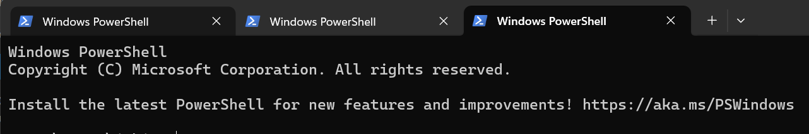

Method of Payment- Free Trial / Pay as you go